Autumn 2015
Senior Pet Focus
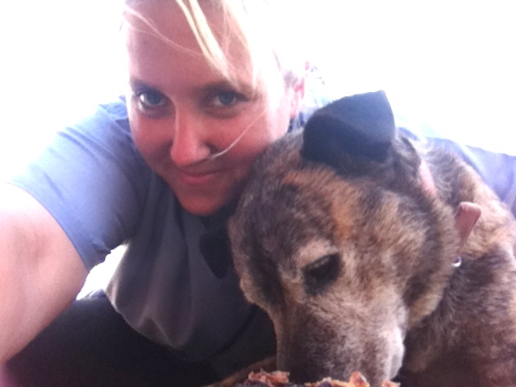
Time flies. It doesn’t take long for the cuddly bundle of joy we get as a puppy or kitten to become a “senior” dog or cat. Unfortunately, our pets age far more quickly than we do. It varies with breed and species but in general pets over 7 years of age can be considered to be senior citizens.

Like people, as they age our pets are more prone to developing a number of common problems. If your mate is getting slower and seems to be enjoying life less, it may not just be because they are “getting older” , they may be suffering from one of the following common conditions.

Osteoarthritis or joint inflammation can cause pain, lameness, decreased mobility and willingness to exercise and can make your pet very grumpy. We can offer many treatments to relieve the pain of arthritis and slow the progress of the disease to keep your mate active and comfortable.

Dental disease, effects up to 70% of our senior population. It is rare for our pets to stop eating due to dental disease but remember that a smelly breath is not normal; it means your dog has an infection in their mouth. If their gums are inflamed it means they will be in pain. Bacteria from Oral infections can also affect their kidneys and hearts.

Obesity; is very common in our older pets. Their metabolism slows, they are fed too much and they don’t get enough exercise. We are all too aware of the adverse effects being overweight can cause.

Cancers are also unfortunately very common in older animals. It is important to check out any lumps and bumps on the skin, have your pets lymph nodes and belly palpated and their chest listened to on a regular basis. Early detection can often be the key to survival.

Heart Disease, Kidney disease, Diabetes, Thyroid disease, Endocrine gland disorders are all far more common in our pets than most people realise. They can be diagnosed with blood and urine tests. If detected early our patients have a much better prognosis for long term control of these problems.

Behavioural problems, a change in your pets’ behaviour may indicate an underlying problem. Blindness, deafness and pain can all cause changes in your pets’ behaviour.

Timely detection of problems in our older pets can often be the difference between a long and happy life or losing a mate early or having them in pain. Because of this at Toowoomba Veterinary Hospital we offer discounted senior pet check-ups (recommended every 6 months) and free dental check-ups.

Our surgery nurse Tracey is pictured above with her senior furry friend Sabre!

Peak to Park for Melanoma!
Thank you SO much to everyone who supported Dr Sasha and Tiffany in their epic 10km run in the cow suits!! All up they raised $2124.60 for the Melanoma Foundation, to help raise awareness and hopefully one day find a cure, for this all too common and devastating disease. Special thanks to Dr Jodi and Dr Zoe from Pittsworth Vet Surgery who helped us fundraise and joined the herd on the day!

Did you know...  We offer a 24 hour emergency service?  By calling 4632 8333 at any time of day or night you will always be able to receive Veterinary advice and care from one of the Veterinarians you  know and trust. | Staff Profile – Gemma Hunt  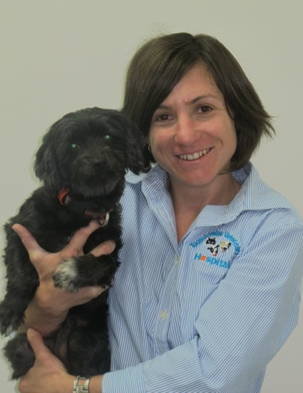  Gemma graduated with an Applied Science degree, majoring in Veterinary Technology in 2012 and soon began working in a rural mixed animal practice in Dalby. She grew up in rural Queensland and finds Toowoomba the perfect balance of city/country living. She enjoys all aspects of work within a veterinary clinic as well as interacting with a wide variety of animal species including cats, dogs, horses, cattle and wildlife. In her spare time Gemma enjoys riding her horses Doc and Sammy and competing in the equestrian sport of eventing. She is also kept busy looking after her two cats; 17 year old Thomas and rescue cat Mannie as well as her adorable (and neurotic) little dog Tess.

