** Autumn 2016**

***Rat Bait Toxicity – Poisoning***

With autumn and then winter almost upon us people tend to put out rat bait as the mice and rats search for warmer homes! Both dogs and cats can be affected by ingesting rat bait directly or by ingesting rodents which have ingested rat bait. It is a condition to be taken seriously and early diagnosis and treatment may prove life saving.

**What types of rat bait are there?**

[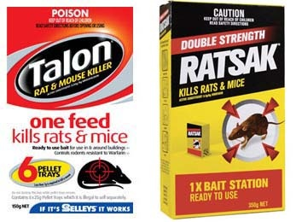](http://www.google.com.au/url?sa=i&rct=j&q=&esrc=s&source=images&cd=&cad=rja&uact=8&ved=0CAcQjRw&url=http://essendonvet.com.au/pet-library/rat-bait-toxicity-poisoning&ei=NfhaVZjJN4Xj8gW8roHwAg&bvm=bv.93564037,d.dGc&psig=AFQjCNH6Xig99Y14L4oNFGh6yF7qHp30Ng&ust=1432111527479786)There are two major types of rat bait: 1st generation drugs such as Ratblitz (active ingredient: Warfarin) have a short duration of action and require ingestion over a long period of time to be fatal, and 2nd generation drugs such as Talon and Ratsak (active ingredient: Brodifacoum) which have a long duration of action and a single dose may prove fatal. Please remember that there is no such thing as a “*pet friendly*” rat bait.

**How will rat bait affect your pet?**

Rat bait acts as an anticoagulant (prevents the blood from clotting) by depleting the body's supply of vitamin K. Vitamin K is a fat soluble vitamin which is essential in the formation of clotting agents in the blood stream. It can take anything from 1-5 days after ingestion to begin to see the signs of intoxication.

**What are the signs of rat bait toxicity?**

[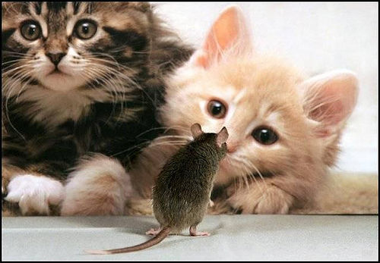](http://www.google.com.au/url?sa=i&rct=j&q=&esrc=s&source=images&cd=&ved=0ahUKEwi5jNal64zLAhUGk5QKHZCFBUwQjRwIBw&url=http://www.digitaljournal.com/article/266673&psig=AFQjCNHvZoEC-uz65wrVedz0XHFr446rOw&ust=1456280856394884)Signs of intoxication are associated with bleeding and can range from very subtle signs such as pin point haemorrhages on the gums to frank bleeding from anywhere. When the body's clotting mechanism is working properly, these damages are repaired immediately without us being aware of it. However, when our clotting system is not working, these minute traumas are not repaired and continue to bleed and thus may result in any of the following signs:-

* pale gums or small pin point haemorrhages on the gums
* lethargy, vomiting or diarrhoea
* bruising under the skin, coughing or respiratory difficulties
* blood in the urine or faeces
* bleeding from the nose, seizures or muscle tremors
* continued bleeding from small wounds or cuts

**What does treatment involve?**

It is very important to ring your Vet immediately. They will advise you to bring your pet into the Clinic as soon as possible. Within a three or four hour time frame of the animal ingesting the rat bait it is possible for the Vet to induce vomiting. Blood may need to be taken for clotting tests and to assess for anaemia. Treatment may be as simple as giving vitamin K tablets for 3-6 weeks or may require more intensive treatment such as blood transfusions and hospitalisation.

***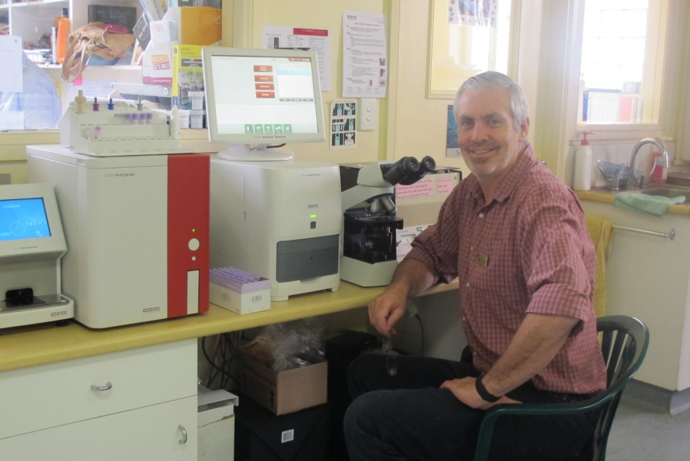What’s New!***

**Our In House Blood Testing** – this preventative care testing is very important for us to spot potential health issues before symptoms show. A pre anaesthetic blood test prior to any surgical procedure will allow us to ensure that there aren’t any underlying issues. Testing can reduce risk and consequence. These tests provide baseline levels for your pet and become part of his or her medical history for future reference. We have recently upgraded our testing equipment and expanded the range of tests that we can offer. Please ask our friendly staff for further information.

**[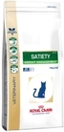](http://www.royalcanin.com.au/products/products/vet-products/vet-diet-feline/satiety-weight-management-dry)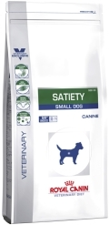Royal Canin Satiety for Cats & Dogs – Weight Management**

Helps your dog feel full on fewer calories with a special blend of fibres that promote **satiety** as well as support for bone and joint health

Helps your cat feel full while managing weight with a special blend of fibres that promote **satiety** as well as support for skin, coat, and urinary health.

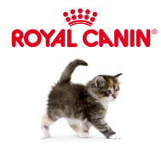Helps your pet to lose weight which will give them a new lease on life and helps to reverse the health risks associated with obesity.

[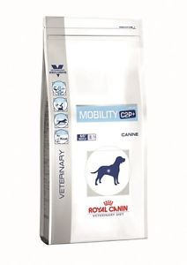](javascript:;)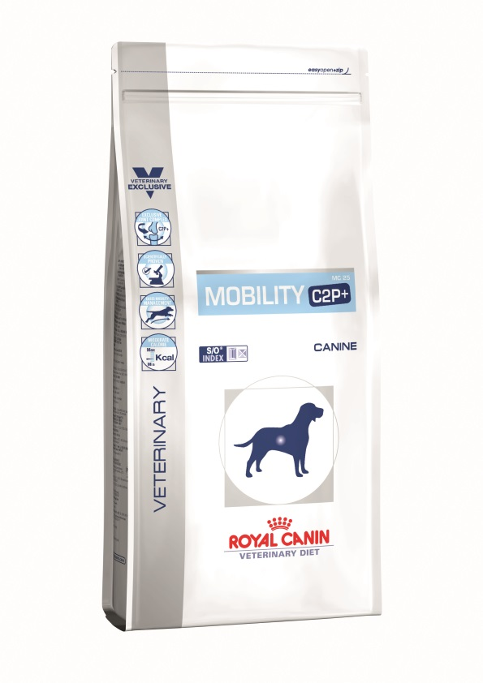**Royal Canin Mobility C2P +**

Helps maintain mobility in dogs. Omega 3 fatty acids from fish oil help reduce inflammation in joints.

The C2P+ cocktail contains turmeric extract, hydrolysed collagen and green tea extract that helps support joint health and reduce inflammation.

|  |  |
| --- | --- |
| **Did you know...**  **We offer a 24 hour emergency service?**  first_aid_kit.gifIf you have a sick or injured pet you can call 07 4632 8333 and one of the Vets you know and trust will help you out | **Staff News** – **Dr Rebecca Welsh.** Rebecca grew up in Toowoomba and she graduated from The University of Queensland in 2011. After two years working in a rural mixed practice in Northern NSW she ventured overseas to the UK. She spent two years doing locum work and travelling around Europe. Rebecca has two Cavalier King Charles Spaniels named Leela and Buffy. She enjoys competing with her  horse Izzie at Eventing trials.Rebecca Welsh.jpg |