Spring 2015
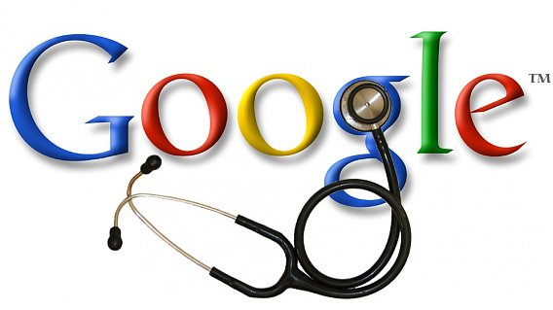
“Dr Google”

Most of us use it every day – Google. We “Google” places to eat, stay, definitions, sport, and the news – you name it. Now, with so much access to information it is all too easy to simply type in your pet’s symptoms and find a presumptive diagnosis.

Over 60% of clients will have “Googled” their pet’s condition before making an appointment to see their vet. There are some excellent resources online from respected and proven resources. Unfortunately there are many not so, often providing misleading and even dangerous advice.

Some problems with “Google-ing” your pet’s condition

- A lot of conditions in our furry 4 legged friends vary a lot on their signalment; breed, age, health status and previous medical conditions. For example, if you “Googled” cruciate repair techniques in dogs, the treatment is very different for Milly the Mini toy Poodle to Borris the Great Dane.
- Google can often scare you. The most common one we see is when owners think a lump may be a type of cancer. A physical examination of your pet and a very quick test can help confirm or dispel any concerns.
- Google can often confirm a “wrong” diagnosis. For example a vomiting puppy; Dr Google may tell you it is just a tummy upset and set your concerns at bay when it could be something far more serious such as an obstruction, congenital deformity, viral or bacterial infection or other cause.

Some benefits of “Google-ing” your pet’s condition

- Reading about your pet’s condition can often help in understanding a complex condition, for instance tract issues in a cat. However, it is very important to have a diagnosis by your vet before you check with what Dr Google has to say!

Our advice?

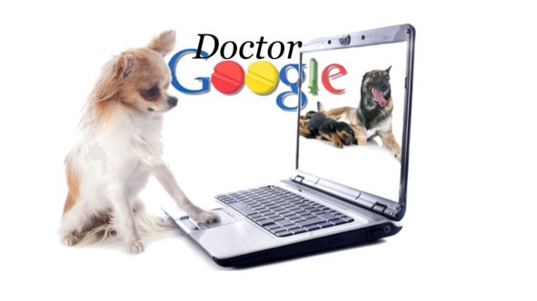
Call us, our staff are all highly trained and have a wealth of experience and knowledge. If one of our nursing staff are unable to assist you, a Vet will be consulted and the information passed on. We pride ourselves at Toowoomba Veterinary Hospital in providing the best possible care for your pet. If you would like more information on a specific condition we will happily provide you with a veterinarian reviewed article.

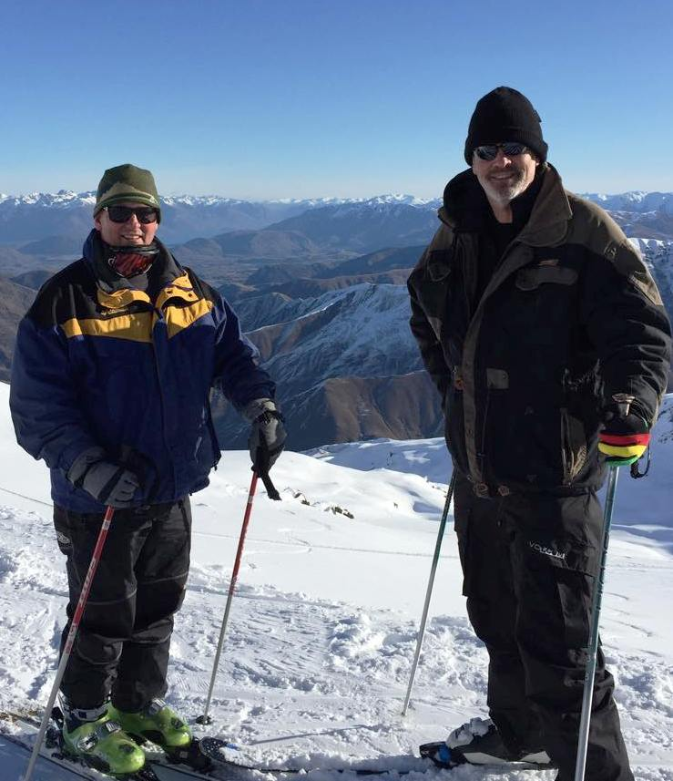
Lake Wanaka Conference
Providing the Best Care by keeping up with the newest advances in veterinary medicine....
Last month Dr Paul travelled to Lake Wanaka in New Zealand for a veterinary conference focussing on small animal medicine, neurology and ophthalmology. One of the many new things at the conference was the advent of a more advanced blood test for the screening of kidney disease in our older cats. This test will pick up kidney disease far earlier than current tests are able to. This early detection will allow us to treat the condition sooner to ensure our cats live a longer and healthier life. We hope to have this test available in clinic soon. It will become an important part of the regular wellness checks for our senior pets.

Dr Paul is pictured here with his friend and colleague Dr Jim Donaldson discussing kidney disease in cats. So he said!!

Tough Mudder !!!!
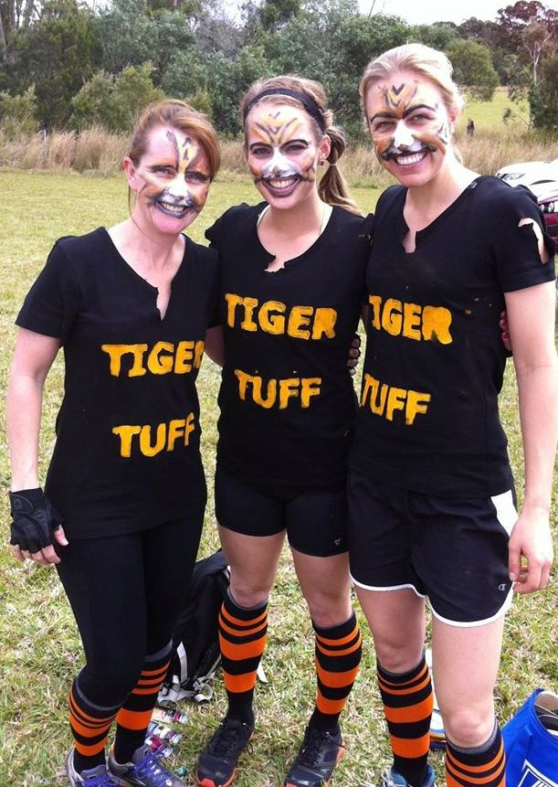
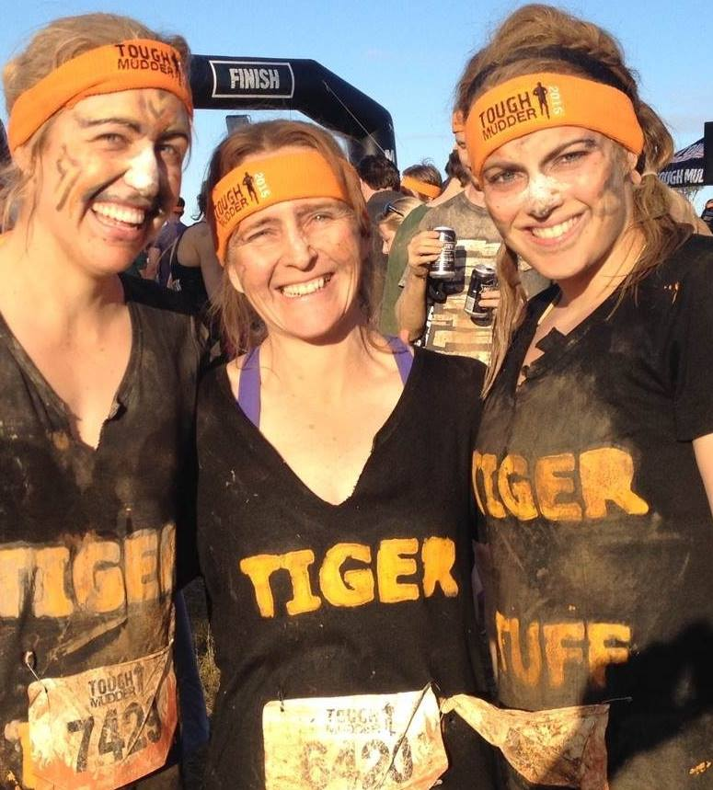
We’re all about staff camaraderie at Toowoomba Veterinary Hospital and 5 months ago Tiff had the idea that we should participate at Tough Mudder! Roy Pistorius, Alison’s husband did a training session for us every Friday evening – when the crunch came in early September it was Sash, Tiff and Ali who stepped up – all funds supporting Soldier On –a charity that supports present and ex-service men and women. Thanks to Roy and Scott for their able assistance getting over the 20 obstacles over 20km!
Fun was clearly had by all !!!

Did you know...  We offer a 24 hour emergency service?  By calling 4632 8333 at any time of day or night you will always be able to receive Veterinary advice and care from one of the Veterinarians you  know and trust. | Staff News – Our nurse Gemma Hunt is pictured below riding her horse Doc – Gemma has recently returned to eventing. She is pictured here participating at the Warwick Horse Trials.  