Summer 2015
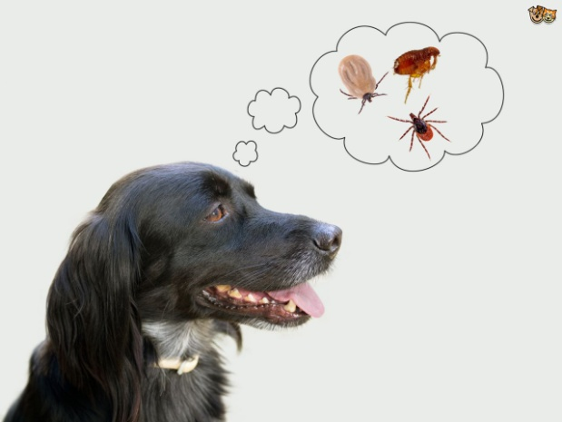
It’s Summer! Scratching, Storm Phobias and Snakes!
It‘s summer already, the days are longer and we’re out and about with our pooches or in the air con with our cats! This month we are focussing on a compilation of summer related illnesses that are relevant to all pet owners.
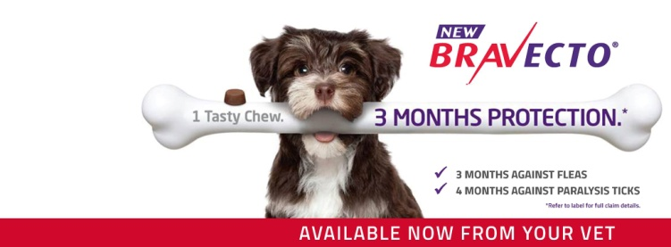
Scratching can mean Fleas! This time of the year, hundreds and thousands of flea larvae are hatching from eggs which have lain dormant all winter driving us and our pets crazy! Remember your dog or cat can bring home just one flea which can then lay up to 300 eggs in your environment. Apart from causing immense irritation and skin infections fleas also carry tapeworm which can infect us and our children.
Our recommendation is to keep your pets on flea and tick prevention all year round. Bravecto is a 3 monthly chew that is palatable and works effectively against paralysis ticks and fleas while Nexgard is a monthly chew which works in a similar way.

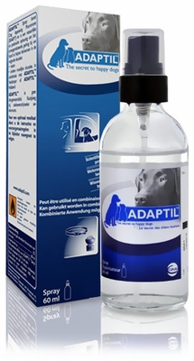
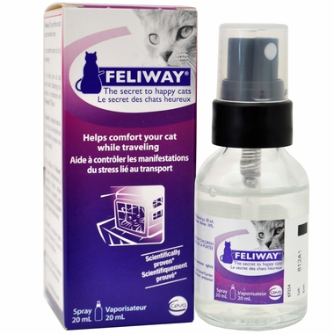
Storm Phobias – Just like we are afraid of spiders, snakes or roller coaster rides, many of our pets can become petrified in a storm.
What you can do;
Trial anti-anxiety medical management – chat to our friendly staff about Adaptil and Feliway for your dogs and cats
Have your pet safely secured and avoid positive reinforcement of their storm related phobias

Have your pet examined by a vet and started on medical treatment
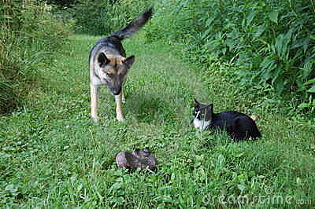
Snakes - We have seen an uncharacteristically high number of snake cases already this year. Keep your cats inside where possible and when gardening or mowing keep your pets tied up or inside. Check them more regularly and have them examined by a vet if they are seen to be playing with or have killed a snake – the signs can be varied and are often apparent straight away but some snake venoms take longer to have an effect and can get sick up to 1-2 days after the initial bite. Prompt veterinary care gives the best possible outcome and treatment with anti venom.
Christmas 2015 We would like to wish all of our clients (both four and two legged!!) a very happy and safe Christmas and best wishes for a wonderful New Year !!
Tried and Trusted
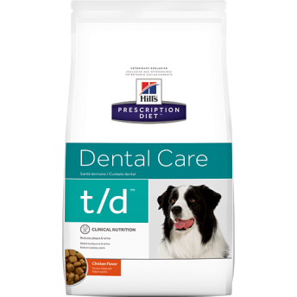
In this section of the newsletter we like to focus on a new product – but we haven’t moved on from our favourite one from last season – Bravecto – the 3 monthly flea/tick chew so we thought we would compile our vet’s favourite tried and tested products to keep your pets fit and healthy this summer
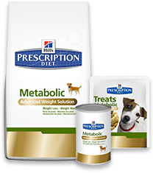
Dr Sasha – Hill’s t/d “This is the single best thing you can feed your pets to look after their teeth. It manually breaks down plaque and after your pet has had a dental it reliably keeps them clean. Dogs and cats love it and it is completely nutritionally balanced”
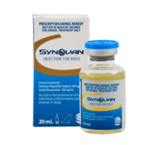
Dr Maddy – Hill’s metabolic food “Losing weight is hard for pets too. 90% of overweight and obese pets when fed this diet as their sole source of food for a defined time period will reach their ideal weight. Maintaining a healthy weight has many health benefits for our pets, just like it does for us”
Dr Louis – Synovan injections “We don’t just see arthritis flare up in winter – these injections are a potent form of pentosan polysulphate and glucosamine – specifically targeting the joint itself – increasing joint fluid and down regulating the mechanisms behind arthritis. Benson, my Labrador has an arthritic elbow and these injections make sure he keeps up with my three kids”

Did you know...  We offer a 24 hour emergency service?  If you have a sick or injured pet you can call 07 4632 8333 and one of the Vets you know and trust will help you out | 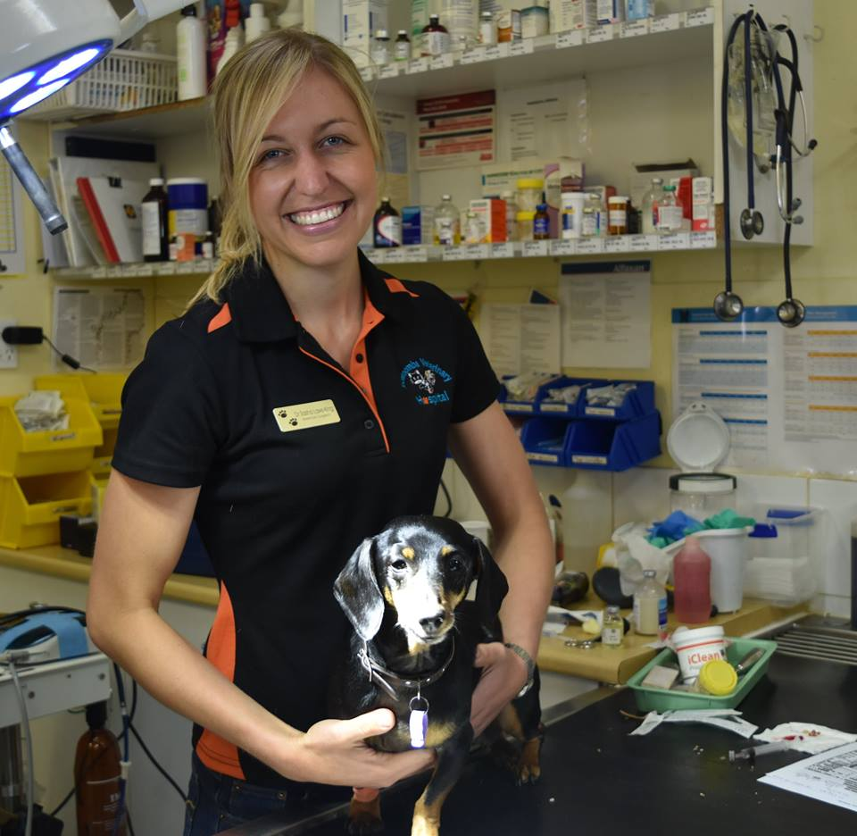  Staff News – Our lovely Dr Sasha has found true love and will be leaving us just after Christmas to be near her partner in Beaudesert. We would like to thank Sasha for her hard work and dedication over the past three years. We really appreciate all that she has done at Toowoomba Veterinary Hospital and we wish her all the best as she embarks on the next chapter!

