Summer 2018
Help us keep your pet healthy with pre-anaesthetic blood testing…To ensure that your pet can properly tolerate an anaesthetic, we run blood tests to confirm that their organs are functioning properly and to find any hidden health conditions that could put your pet at risk.
The top four reasons to test your pet before anaesthesia are;
- Detect hidden illness – healthy looking pets may be hiding symptoms of a disease or aliment. Testing helps detect this kind of illness, so we can avoid problems with anaesthesia.
- Reduce risks and consequences – if the pre-anaesthetic testing results are normal, we can proceed with confidence. If not, we can alter the anaesthetic procedure or take other precautions to safeguard your pet’s health.
- Protect your pet’s future health – these tests become part of your pet’s medical record, providing a baseline for future reference.
- Enjoy peace of mind – testing can significantly reduce medical risk.
Our in-house facilities mean that this testing can be done in clinic with results being available within ten minutes. Our Vets can then make informed decisions. If you’ve any questions, please ask any one of our Vets or Nurses who would be delighted to chat with you in more detail about this important process.
Early Detection, Early Intervention…..

Products we love!

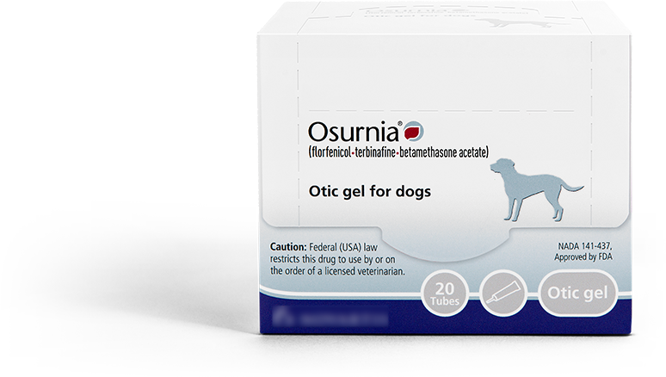
Ear infections are one of the most common reasons dogs present to a vet. Otitis externa (ear infection) is most commonly caused by allergies, ear mites, or a foreign body (eg.grass seed). Osurnia treats ear infections in just 2 doses one week apart. Osurnia applies like a liquid and then becomes gel like which ensures that it stays in the ear.

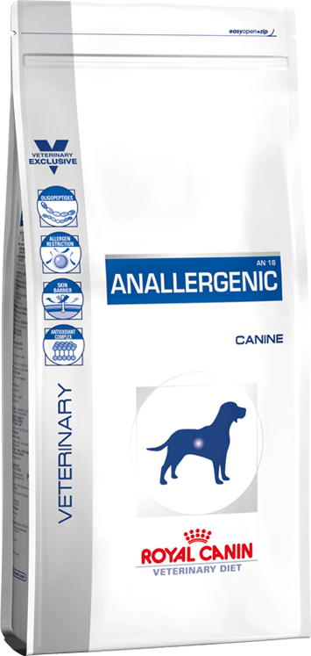

Anallergenic is a scientifically formulated and unique nutritional solution for dogs and cats with severe dietary allergies. Anallergenic is formulated to assist in the management of severe adverse food reactions in dogs. The complete diet includes hydrolysed protein sources and carefully selected carbohydrates to reduce skin and digestive reactions.
We’ve extended our weekend opening hours!! Saturday 8.00am – 5.00pm & Sunday 9.00am – 4.00pm

Did you know...  We offer a 24-hour emergency service?  If you have a sick or injured pet you can call 07 4632 8333 and one of the Vets you know and trust will help you out | Staff News –Most of you will recognize Alice as one of our Vet Nurses. She has worked with us for the past six years while studying Veterinary Science at UQ Gatton.  In January this year we were delighted to welcome Dr Alice!!  Alice has graduated from UQ Gatton and joined our team of Vets. Congratulations & well-done Dr Alice 😊  