**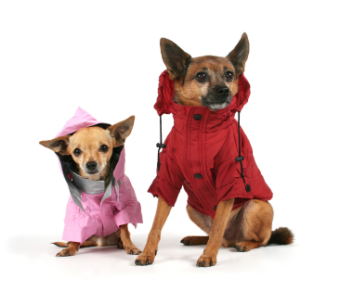Winter 2016**

***Our Pets in winter***

Winter chills have struck and lots of us are finding it hard to get out of bed in the morning. Many of our fur babies can find winter tough as well, particularly those suffering from Osteoarthritis.

Nearly a quarter of pets suffer from Osteoarthritis/Degenerative Joint Disease (OA/DJD). It is particularly common in older larger breeds but can occur in dogs and cats of any size or age. It is a painful and debilitating condition.

Many dogs may have difficulty rising after rest or can be obviously lame but other pets can have more subtle signs. If they are getting a little slower, falling behind on walks, reluctant to walk up or down stairs, or jump into vehicles, are chewing at their joints or have a change in personality they may be suffering from Osteoarthritis. Cold, wet conditions often make the symptoms worse.

***What can owners do for dogs with arthritis?***

* Encourage weight loss
* Provide soft bedding
* Moderate exercise
* Provide ramps to get up stairs and into cars
* Do not give them human arthritis medication – we have seen a number of dogs with gastric ulceration from being given medication meant for humans.
* Visit your Vet

We will give your dog a thorough clinical examination to determine if Osteoarthritis is the cause of their problems. If required we can X-ray them to confirm the diagnosis.

We have a number of very effective medications available for treating OA/DJD. What we prescribe depends on the individual, the joints affected and any other medical conditions they may be suffering. We get excellent results in most arthritic pets with a series of injections that help to repair damaged cartilage and restore normal joint fluid. We often use oral NSAIDS, anti-inflammatory drugs that provide excellent pain relief. Special diets or dietary supplements can also help.

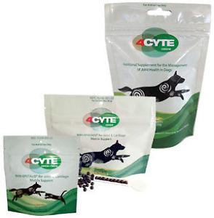Remember age is not a disease, so if your pet has arthritis they don’t have to suffer this winter.

**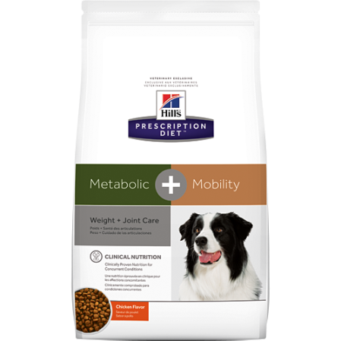What’s New!**

Just like the human population there is a growing trend for our pets to be overweight. Obesity in pets can predispose them to heart disease, joint disease and diabetes among other chronic ailments.

***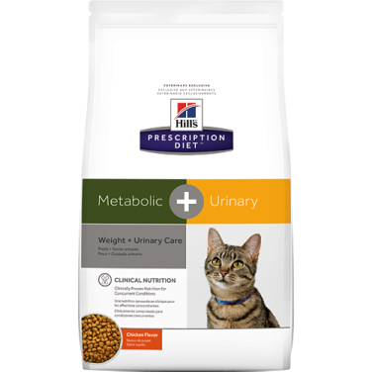Hills Canine Metabolic plus Mobility*** is perfect for overweight dogs with Osteoarthritis. Its unique formulation with Omega-3 fatty acids, Glucosamine and Chondroitin helps to directly improve joint health while also ensuring your dog loses weight. As we know weight loss is vital to improve mobility in our arthritic patients.

***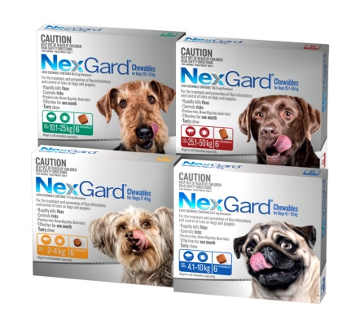Hills Feline Metabolic Plus Urinary*** - urinary tract disease is a very common problem in our feline friends. For many years we have been able to control this issue with Hills c/d diet which helps dissolve bladder stones and prevents UTI’s. With this new diet we can get our overweight pussies to lose weight while still preventing recurrent bladder issues.

***Tick and Flea Prevention***

Many people tend to think that fleas and ticks are a warm weather problem and get complacent about treating their pets in winter. With more of our pets living inside our warm houses with us, fleas are a big problem year round. In fact, we often see more dogs and cats with issues due to fleas through the winter because they haven’t been getting their prevention.

Paralysis ticks are a huge problem from September to January but going back through our records we see tick cases in every month of the year. With the recent rain we have treated two dogs with tick paralysis already this June.

The producers of Nexgard and Bravecto are both offering incentives on purchases this winter. Please ask our staff for further information.

|  |  |
| --- | --- |
| **Did you know...**  **We offer a 24 hour emergency service?**  first_aid_kit.gifIf you have a sick or injured pet you can call 07 4632 8333 and one of the Vets you know and trust will help you out | **Staff News** – Travis Sanderson**.**  IMG_4503.JPGTravis is studying the Cert IV in Veterinary Nursing with Open Colleges. He joins us for one and a half days each week as part of his work placement. He is pictured here with a little Joey rescued from the side of the road (which has since been given to a carer). Travis has a 10 year old Beagle named Jack. Camping is a favourite pastime. He is really enjoying his Vet nursing course and is looking forward to qualifying in 2017. |