Winter 2017
New Laws for Dog Breeders
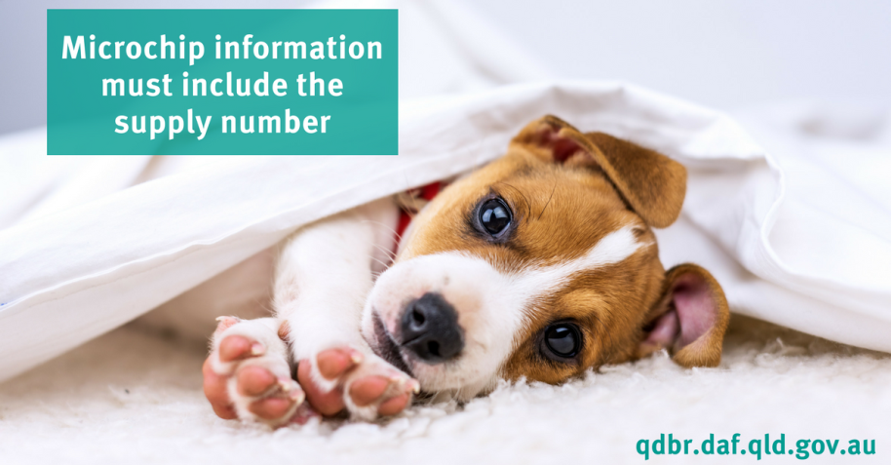
The Queensland Government have introduced mandatory dog breeder registration from 26 May 2017. Anyone who breeds a dog will have to register as a dog breeder. This includes professional, occasional and accidental breeders. All breeders must have a supply number which is free and can be obtained by registering through the Queensland Dog Breeder Register website at www.qdbr.daf.qld.gov.au
A key purpose of this new requirement is to promote the responsible breeding of dogs and puppies in Queensland. Of direct relevance to our clients is that we will be unable to microchip your new puppy or litter of puppies unless we can include a supply number on the microchip paperwork that we send to the Australian Animal Registry (AAR) on your behalf.
There are penalties for those who give away, sell or advertise a dog or puppy without a supply number. Penalties will also apply to anyone who microchips a dog/puppy without a supply number.
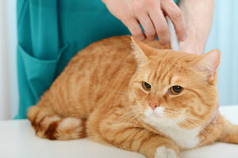
However, if someone presents a dog to be microchipped and they:
- do not know the supply number; and
- are unable to locate the breeder; and
- do not intend to supply the dog to another person
a supply number does not need to be recorded in the microchip information. A declaration form will be signed by both the implanter and the owner and must accompany the microchip paperwork sent to the animal registry.
Another exemption is that Primary producers who breed working dogs do not have to register as breeders as long as they supply all puppies to other primary producers as working dogs. Supply numbers can be checked on the Queensland Dog Breeder Register. For more information, visit the Biosecurity Queensland website at www.biosecurity.qld.gov.au or call 13 25 23. To confirm a supply number visit the Queensland Dog Breeder Register website at www.qdbr.daf.qld.gov.au
Products we love!

We know that Bravecto is very effective against fleas and paralysis and brown dog ticks. Now there is another reason to consider Bravecto for your canine friends. It has recently been approved by the Australian Pesticides and Veterinary Medicines Authority for the treatment and control of three different types of mite infestations in dogs. It’s worth remembering that just because the weather is cooler doesn’t mean that we can take a few months off using this preventative. Just in the last couple of weeks we have seen an above average number of dogs with tick paralysis. Bravecto are also running a loyality program whereby if you buy four you get the fifth for free.

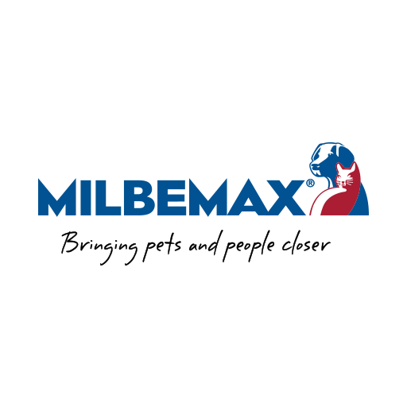
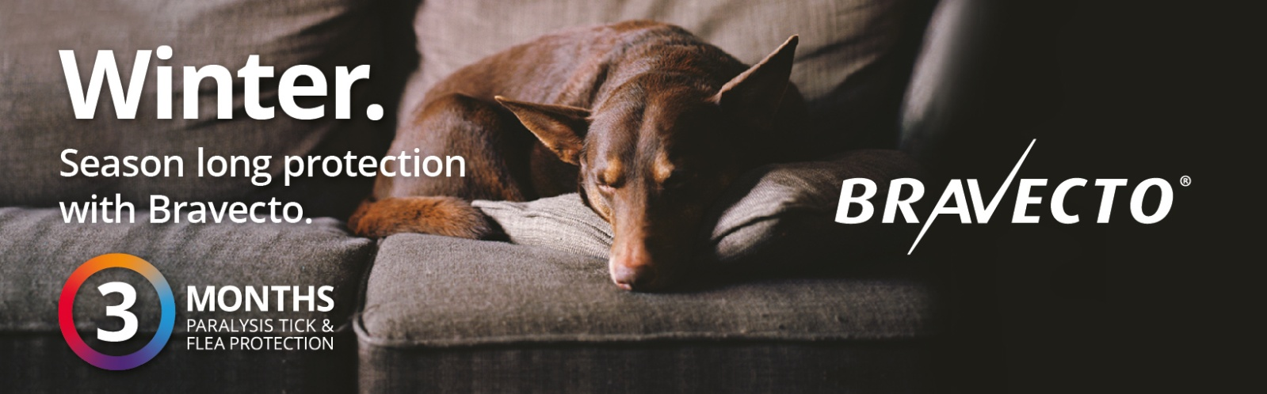

Milbemax™ delivers broad spectrum protection against common intestinal worms and when given every 3 months treats and controls hookworm, roundworm and tapeworm in dogs and cats. It also treats and controls whipworm in dogs. With just one tiny tablet every 3 months, Milbemax™ provides the ultimate convenience. And being the smallest all-wormer tablet for cats and dogs on the market, it’s easy for both you and your pet. To make it easier to remember we suggest giving Bravecto and Milbemax at the same time as they are both given quarterly. We will send you a reminder text message when they are due.
Did you know...  We offer a 24 hour emergency service?  If you have a sick or injured pet you can call 07 4632 8333 and one of the Vets you know and trust will help you out | 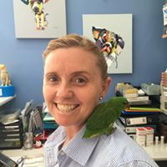  Staff News – Our nurse Chantal has recently completed a continuing education course through the James Cook University. The course focused on Anaesthesia. She found it to be extremely interesting and informative focusing on different techniques and medications for various emergency and surgical procedures.

